**פתרון תרגילים מחוברת תרגילים**

**פרק 20 - Views using eDate**

1.

a.

create view Operation.SomeInvitations_v

as

select Id,RequestingSessionId,ReceivingMemberId,CreationDateTime,StatusId,ResponseDateTime

from Operation.Invitations

where StatusId = (select Id from Lists.InvitationStatuses where Name = 'Denied')

b.

insert into Operation.SomeInvitations_v values (1001,100003,getdate(),1,null)

c.

alter view Operation.SomeInvitations_v

as

select Id,RequestingSessionId,ReceivingMemberId,CreationDateTime,StatusId

from Operation.Invitations

where StatusId = (select Id from Lists.InvitationStatuses where Name = 'Denied')

d. Cannot insert because column doesn't exist.

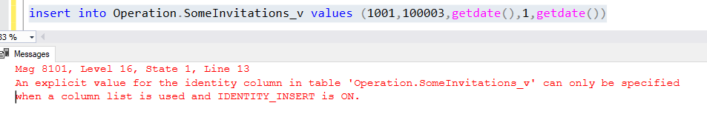

e.

insert into Operation.SomeInvitations_v values (1002,100003,getdate(),1)

f.

alter view Operation.SomeInvitations_v

as

select Id,RequestingSessionId,CreationDateTime,StatusId

from Operation.Invitations i

where StatusId = (select s.Id from Lists.InvitationStatuses s where s.Name = 'Denied')

g. Cannot insert this row because the original table doesn't allow nulls in the ReceivingMemberId column, which was removed from this view:

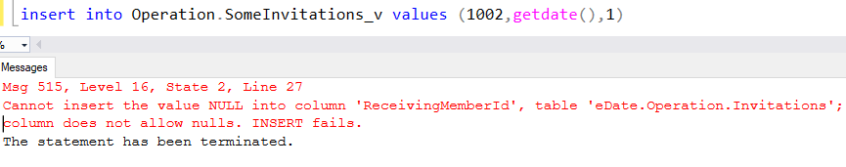

h. Return the above column back:

alter view Operation.SomeInvitations_v

as

select Id,RequestingSessionId,ReceivingMemberId,CreationDateTime,StatusId

from Operation.Invitations

where StatusId = (select Id from Lists.InvitationStatuses where Name = 'Denied')

i.

insert into Operation.SomeInvitations_v values (1002,100003,getdate(),2)

j.

alter view Operation.SomeInvitations_v

as

select Id,RequestingSessionId,ReceivingMemberId,CreationDateTime,StatusId

from Operation.Invitations

where StatusId = (select Id from Lists.InvitationStatuses where Name = 'Denied')

WITH CHECK OPTION

k. Cannot insert the row from section "i" because of the check constraint:

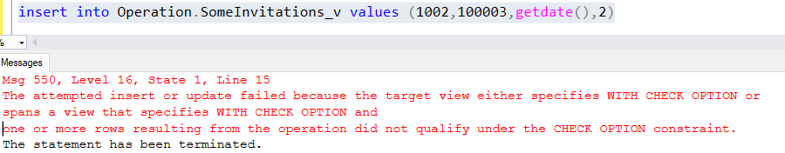

l.

alter view Operation.SomeInvitations_v

as

select i.Id,i.RequestingSessionId,i.CreationDateTime,i.StatusId,ms.MemberId

from Operation.Invitations i

join Operation.MemberSessions ms on i.ReceivingMemberId = ms.MemberId

where i.StatusId = (select s.Id from Lists.InvitationStatuses s where s.Name = 'Denied')

m. Cannot insert row into the view that based on few tables:

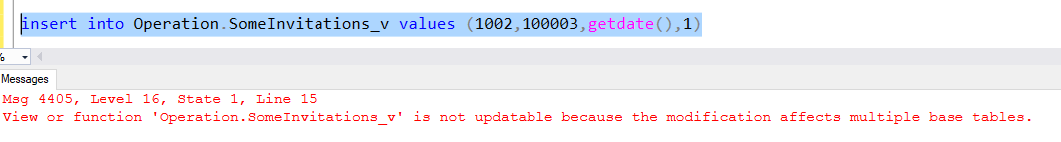

n.

create view Operation.MemberSessionsView

as

select ms.Id,ms.MemberId,

cast(ms.LoginDateTime as date) as LoginDate,

cast(ms.EndDateTime as date) EndDate,

coalesce(sr.Name,'') as EndReason

from Operation.MemberSessions ms

left join Lists.SessionEndReasons sr on ms.EndReasonId = sr.Id

o. Use the above created view:

create view Operation.LastMonthSessions

as

select Id,MemberId,LoginDate,EndDate, EndReason

from Operation.MemberSessionsView msv

where year(LoginDate) = year(getdate()) and month(LoginDate) = month(getdate()) - 1

p.

create view Operation.SingleMemberSessions

as

select ms.Id as SessionId, ms.MemberId, m.FirstName + ' ' + m.LastName as MemberName,

cast(ms.LoginDateTime as date) as LoginDate,

cast(ms.EndDateTime as date) EndDate,

coalesce(sr.Name,'') as EndReason

from Operation.MemberSessions ms

join Operation.Members m on ms.MemberId = m.Id

left join Lists.SessionEndReasons sr on ms.EndReasonId = sr.Id

where m.MaritalStatusId = (select Id from Lists.MaritalStatuses where Name = 'Single')

q.

create view Operation.MemberSessionStatistics

as

select c.Name as Country, g.Name as Gender, mrt.Name as MaritalStatus,

count(ms.Id) as cnt_sessions,

avg(DATEDIFF(MINUTE,ms.LoginDateTime,ms.EndDateTime)) as averageSessionDuration

from Operation.MemberSessions ms

join Operation.Members m on ms.MemberId = m.Id

left join Lists.Countries c on m.CountryId = c.Id

left join Lists.Genders g on m.GenderId = g.Id

left join Lists.MaritalStatuses mrt on m.MaritalStatusId = mrt.Id

where ms.EndDateTime is not null

group by c.Name, g.Name, mrt.Name

r.

alter view Operation.MemberSessionStatistics

as

select c.Name as Country, g.Name as Gender, mrt.Name as MaritalStatus,

count(ms.Id) as cnt_sessions,

avg(DATEDIFF(MINUTE,msf.LoginDateTime,msf.EndDateTime)) as averageSessionDuration

from Operation.MemberSessions ms

join Operation.Members m on ms.MemberId = m.Id

left join Lists.Countries c on m.CountryId = c.Id

left join Lists.Genders g on m.GenderId = g.Id

left join Lists.MaritalStatuses mrt on m.MaritalStatusId = mrt.Id

left join (select * from Operation.MemberSessions where EndDateTime is not null) msf on ms.Id = msf.Id

group by c.Name, g.Name, mrt.Name

s.

create view Operation.FemaleItalianMembers

as

select Id as MemberId,

FirstName + ' ' + LastName as MemberName,

cast(RegistrationDateTime as date) as RegistrationDate

from Operation.Members m

where m.CountryId = (select Id from Lists.Countries where Name = 'Italy') and

m.GenderId = (select Id from Lists.Genders where Name = 'Female')

t.

select fim.MemberId, fim.MemberName,ms.Id as SessionId, ms.LoginDateTime

from Operation.MemberSessions ms

join Operation.FemaleItalianMembers fim on ms.MemberId = fim.MemberId

where year(ms.LoginDateTime) = year(getdate()) - 1

u. Not possible, because there are a lot of not nullable columns that were not mentioned in the view and also the view has a computed columns (Member Name and Registration Date (which is not datetime like in the origin table)).

v. Remove the computed columns and add all the not-nullable columns from the origin table:

alter view Operation.FemaleItalianMembers

as

select Id as MemberId,

FirstName,

LastName,

RegistrationDateTime as RegistrationDate,

Username,Password,CountryId,EmailAddress,GenderId,BirthDate

from Operation.Members m

where m.CountryId = (select Id from Lists.Countries where Name = 'Italy') and

m.GenderId = (select Id from Lists.Genders where Name = 'Female')

w. Inserted succesfully:

insert into Operation.FemaleItalianMembers

values ('Vika', 'O', getdate(), 'vika2727', '123123', 5, 'q@q', 2, '1986-01-01')

x. Also inserted succesfully:

insert into Operation.FemaleItalianMembers

values ('Israel', 'Il', getdate(), 'israel', '555', 1, 'q@q', 1, '1986-01-01')

y. Cannot insert after the check constraint:

